Night
By: Elie Wiesel

Study Questions
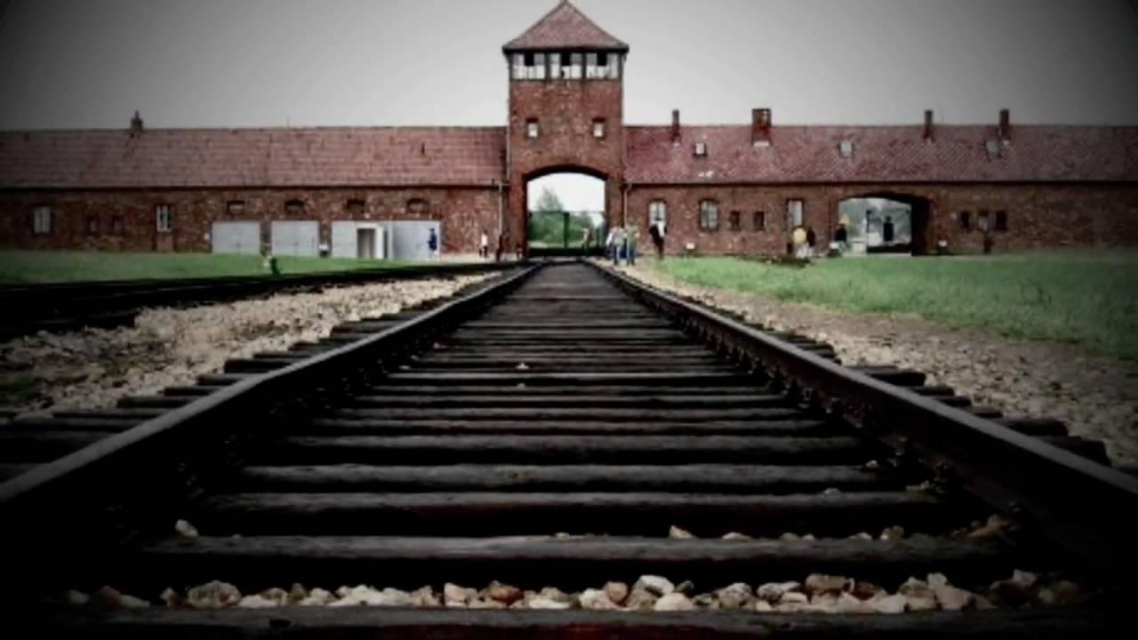

Name: ___________________________________________________ Period: ______________
Night: Chapter 1 Questions Title: _________________________________________

1. Write an example of a simile found on page 1.

2. What does Elie desire to study?

3. Who does he get to help him?

4. What happens to Moishe the Beadle?

5. What does Moishe say happen while he was away?

6. Why don’t any of the townspeople believe Moishe?

7. What kind of position does Elie’s father have in the community?

8. What kind of relationship do Elie and his father have at the beginning of the novel?

9. Where are the Jews sent first after the arrival of the German soldiers?

10. Provide an example of a simile and a metaphor from page 15.

Night: Chapter 2 Questions Title: ________________________________________

1. What news do they then receive of where they are to be located?

2. How many people ride on each train?

3. What does Madame Schachter imagine she sees?

4. Name the literary device Madame Schachter’s “vision” is an example of.

Night: Chapter 3 Questions Title: _________________________________________

1. What happens to Elie’s family when they reach the camp?

2. What advice do Elie and his father receive from one of the camp prisioners?

3. What occupation does Elie say he is?

4. What happens to those who are skilled workers?

5. Write an example of a metaphor found of page 34.

6. What do Elie and the others recite as they are nearing the crematory?

7. What new name does Elie receive at the camp?

Night: Chapter 4 Questions Title: _________________________________________

1. What happens to people with gold teeth or crowns?

2. What type of treatment do the men receive at the factory?

3. How does Elie manage to keep some of his teeth temporarily?

4. What happens to people who disobey the rules of the camp?

5. Why does the hanging of the “pipel” stay in Elie’s mind?

Night: Chapter 5 Questions Title: _________________________________________

1. How do the prisoners celebrate Rosh Hashanah?

2. How do they celebrate Yom Kippur?

3. Why doesn’t Elie celebrate?

4. What advice does the block head give the men before selection?

5. What does Elie’s father give him when he thinks he has been selected?

6. What happens to Akiba Drumer?

7. What promise do Elie and his father make Akiba? Do they keep their promise?

8. Why does Elie go to the doctor?

9. Who does the prisoner next to Elie in the hospital think he has kept the most promises?

10. Why do Elie and his father decide to leave with the evacuation?

11. Name the literary device that this is an example of.

12. Why does the head of the block order the men to clean the barracks before leaving?

Night: Chapter 6 Questions Title: _________________________________________

1. How do the men travel to Gleiwitz?

2. What happens to the men as they travel if they are slow? (2 answers)

3. What is Juliek’s broken violin a symbol of?

4. What happens to the men who fall asleep in the caved-in brick factory where they pause to rest on their journey?

5. What do the men do to make up for the fact that they have nothing to drink? What do the SS do when they see this?

Night: Chapter 7 Questions Title: _________________________________________

1. How do the men treat each other on the train ride to Buchenwald?

2. How many men arrive at Buchewald? How many were originally on the train?

Night: Chapter 8 Questions Title: _________________________________________

1. What does Elie’s father choose for himself?

2. Why does Elie take his father to the doctor?

3. What is the last word that Elie’s father says?

4. What are Elie’s conflicting emotions with his father’s death?

Night: Chapter 9 Questions Title: _________________________________________

1. What does Elie’s only concern become?

2. What do the prisoners never think of after being liberated?

3. What does Elie call himself after he looks in the mirror?

Night: Overall questions to consider

1. List three examples of father/son relationships in the story.

2. What does night symbolize in the novel? Refer to page 32 for help.

3. Name at least two events in the story where Elie expresses his loss of faith.

4. Which characters are witnesses? How?

5. List at least three opportunities Elie’s family had to escape.

6. Consider the title of the novel, Night. Why is this significant? Is it an appropriate title for this text?

