Mrs. Bernardi bernardienglish.weebly.com 2016-2017
English 4 CP
Policies
Now this is not the end. It is not even the beginning of the
end. But it is, perhaps, the end of the beginning.
Tardiness
Policy will be followed according to MCHS Handbook. See page 19 for more information.

Electronic Devices
Personal use of electronic devices is not allowed during class. If one is needed for an assignment, further instructions will be given at that time.

Late Work
Late work is unacceptable. Anything not handed in on time will result in a zero.

Cheating
Cheaters should be punished! It is completely unacceptable, and students will receive consequences, which may include failure of the assignment and/or the class.

Absences
It is the student’s responsibility to request make up work and complete it in a timely manner. If you are not here, you are not learning.

Respect
Respect yourself. Respect your peers. Respect the teacher. Respect the classroom. It’s simple.
--Winston Churchill
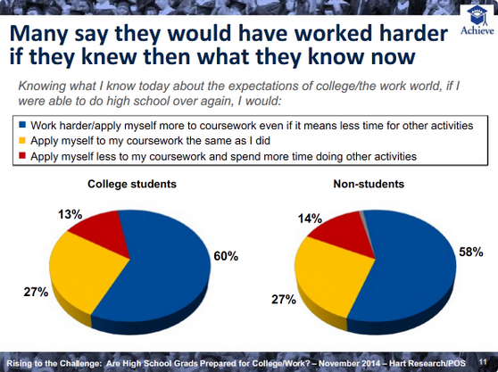
Meet Your Teacher
Education: High School diploma from MCHS; Bachelor’s Degree from Illinois State University in English with Teaching Certificate and a Minor in Spanish.
Favorite Books: To Kill a Mockingbird, The Fault in Our Stars, Salt to the Sea, Out of the Easy, and Me Before You
Athletics/Activities: Head Poms Coach, Yearbook Adviser, Literary Festival Sponsor
Family: Married Pete in July 2014
@MCHSBernardi
Course Description: This course is for those students who are considering college and who have been in college prep English courses or have been recommended from English 3. Instruction will include types of literature, composition, and research.

(1) Unit One: Comparison
Main Text – The Orphan Train by Christina Baker Kline
Simile/Metaphor/Allusion/Shift/Allegory/Flashback
Unit Two: Irony
Main Text – Oedipus/Antigone by Sophocles
Diction/Irony
Unit Three: Characterization
Main Text – Beowulf
Methods of Characterization/Conflict/Stereotype/Archetype/Epic/Epic Hero
Unit Four: Point of View/Narration
Main Text – Night by Elie Wiesel
First Person/Third Person Narration
Unit Five: Term Paper

(2) Unit One: Style/Syntax
Main Text – Canterbury Tales by Geoffrey Chaucer and All Quiet on the Western Front by Erich Remarque
Diction/Sentence Structure/Connotation/Denotation/Syntax
Frame Story/Voice/Tone
Unit Two: Tragedy
Main Text – Macbeth by Shakespeare and Hamlet by Shakespeare
Tragic Hero/Social Commentary/Political Commentary
Unit Three: Setting
Main Text – Lord of the Flies by William Goldberg
Imagery/Mood
Unit Four: Comedy/Satire
Main Text – Gulliver’s Travels by Jonathan Swift
Irony/Hyperbole/Understatement
Juxtaposition/Exaggeration

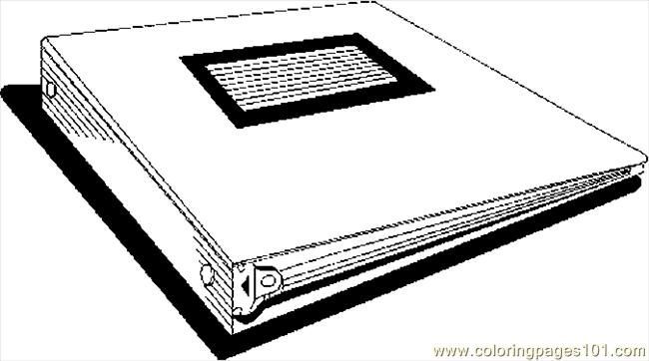
Class Material Requirements
1 1/2 or 2 inch binder
10 Dividers
Spiral Notebook
Pens, Pencils, Highlighters
Post It Notes
Grades: Total Points
80% 18 Week Grade
20% Final Exam

