Mrs. Bernardi bernardienglish.weebly.com 2016-2017
FRESHMAN ENGLISH
Policies
Don’t compare your beginning to someone else’s middle.
-- Anonymous
Tardiness
Policy will be followed according to MCHS Handbook. See page 19 for more information.

Electronic Devices
Personal use of electronic devices is not allowed during class. If one is needed for an assignment, further instructions will be given at that time.

Late Work
Late work is unacceptable. Anything not handed in on time will result in a zero.

Cheating
Cheaters should be punished! It is completely unacceptable, and students will receive consequences, which includes failure of the assignment and an administrative referral.

Absences
It is the student’s responsibility to request make up work and complete it in a timely manner. If you are not here, you are not learning.

Respect
Respect yourself. Respect your peers. Respect the teacher. Respect the classroom. It’s simple.
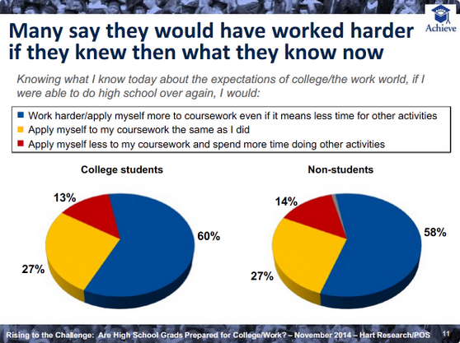
@MCHSBernardi
Meet Your Teacher
Education: High School diploma from MCHS; Bachelor’s Degree from Illinois State University in English with Teaching Certificate and a Minor in Spanish.
Favorite Books: To Kill a Mockingbird, The Fault in Our Stars, Salt to the Sea, Out of the Easy, and Me Before You
Athletics/Activities: Head Poms Coach, Yearbook Adviser, & Literary Festival Sponsor
Family: Married Pete in July 2014

Course Description: This course helps the student develop a general background in four major genres: narrative, novel, poetry, and drama. Included throughout the year are assignments dealing with grammar skills and writing.

Major Texts Used:
(1) Elements of Literature: Third Course
(2) Hound of the Baskervilles by Sir Arthur Conan Doyle
(3) The Odyssey by Homer
(4) Romeo and Juliet by William Shakespeare
(5) Grammar Workbook

Grading Scale:
Grades: Total Points
85% 18 Week Grade
15% Final Exam
(A) 92--100
(B) 83--91
(C) 74--82
(D) 65--73
(F) 0--64

Required Materials: On a daily basis, you need to bring:
1 1/2 inch binder
Labeled dividers
Semester 1: Fiction, Non-Fiction, Novel, Mythology, Grammar & Writing
Semester 2: Poetry, Trojan War, Odyssey, Romeo and Juliet, Grammar & Writing
Pens, Pencils, Highlighters
Post-It Notes
Spiral Notebook (or loose leaf in binder)
MCHS Planner
Grammar Workbook
Current textbook/novel

